EXERCISE NUMBER:2
DATE:10 /10/2020

Aim: To Write a Python function countX(lst, x) to count the number x in a given list of numbers.
Program:
def countX(list,s):
c=0
for i in range(0,len(list)):
if(list[i]==s):
c+=1
print(c)
list=[]
x=int(input())
for i in range(0,x):
list.append(int(input()))
s=int(input())
countX(list,s)

Link:http://103.53.53.18/mod/vpl/forms/submissionview.php?id=230&userid=1746

Output:

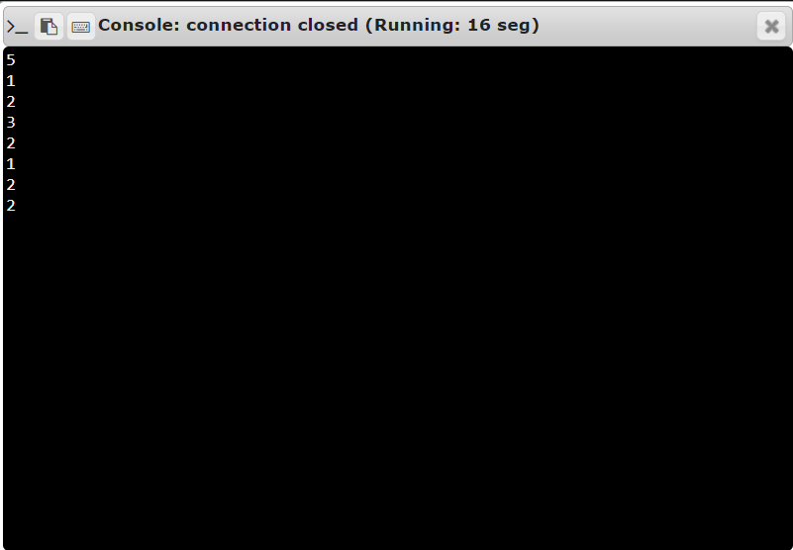

RESULT: The output of this program is verified

